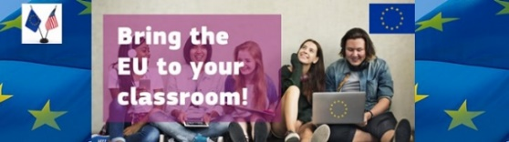
Teaching the European Union in a Transatlantic Context
Friday, January 19th, 2024 | 8:30 a.m. – 3:30 p.m. – FIU – GL 220
Florida International University – Green Library

Please complete and return the following survey to Christine I. Caly-Sanchez – Miami-Florida Jean Monnet Center of Excellence at Florida International University - by e-mail at calyc@fiu.edu
Your thoughts and comments are appreciated.

NamE:
HIGH SCHOOL:

A. WORKSHOP
Respond to the following statements by selecting the box that best matches your opinion.

- Valuable information was provided regarding the workshop on “Teaching the European Union in a Transatlantic Context”
Strongly Agree Agree Undecided Disagree Strongly Disagree

Why?

- The presenters made the information easy to understand.
Strongly Agree Agree Undecided Disagree Strongly Disagree

Comments:

- In participating in the Workshop, did it increase your knowledge of the European Union?
Strongly Agree Agree Undecided Disagree Strongly Disagree
Comments:

- Questions were answered carefully and completely.
Strongly Agree Agree Undecided Disagree Strongly Disagree

Comments:

- A one-day workshop is adequate.
Strongly Agree Agree Undecided Disagree Strongly Disagree

If “Disagree” or “Strongly disagree”, please suggest duration:
Longer day (specify: _____hrs) Additional day(s) (specify: _____day(s)) Shorter day (specify: _____hrs)
…/…

NamE:
HIGH SCHOOL:

Please rate each segment of the orientation:

MORNING

- History of the EU
Excellent Very Good Good Fair Poor
Comments:

- Institutions & Major Policies of the EU
Excellent Very Good Good Fair Poor
Comments:

- Overview Database Literacy for European Union Sources
Excellent Very Good Good Fair Poor

Comments:

- Overview of the Euro Challenge Competition
Excellent Very Good Good Fair Poor

Comments:

AFTERNOON

- Nordics & Relations to China
Excellent Very Good Good Fair Poor

- Migration & LGBT
Excellent Very Good Good Fair Poor

- Russia-Ukraine, Hungary
Excellent Very Good Good Fair Poor

Comments:

B. Recommendations

Suggestions/comments to help make future workshop for teachers better:

If you are interested in receiving our newsletter and upcoming events, please provide your e-mail:

THANK YOU

